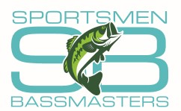 | Sportsmen Bassmasters  Advertising Sponsorship
Dear Sir or Madam:

Sportsmen Bassmasters is one of the oldest and largest bass clubs in Minnesota. We are based in Bloomington, Minnesota but have over 25 active members throughout the Minneapolis area. Our members compete in club, team and individual tournaments that help to contribute to the sport of fishing. We also actively participate in multiple lake clean-up projects and creel survey data collection for the Minnesota Department of Natural Resources. We are especially proud that several of our members were integral in the saving and restoring dock access for an elderly, handicapped lakeshore owner (published in B.A.S.S. Times). Simply stated, the Sportsmen Bassmasters represent one of the largest and most active fishing clubs in Minnesota -- a club that takes pride in its community involvement.

We are asking your business to become a Sportsmen Bassmasters advertising sponsor.

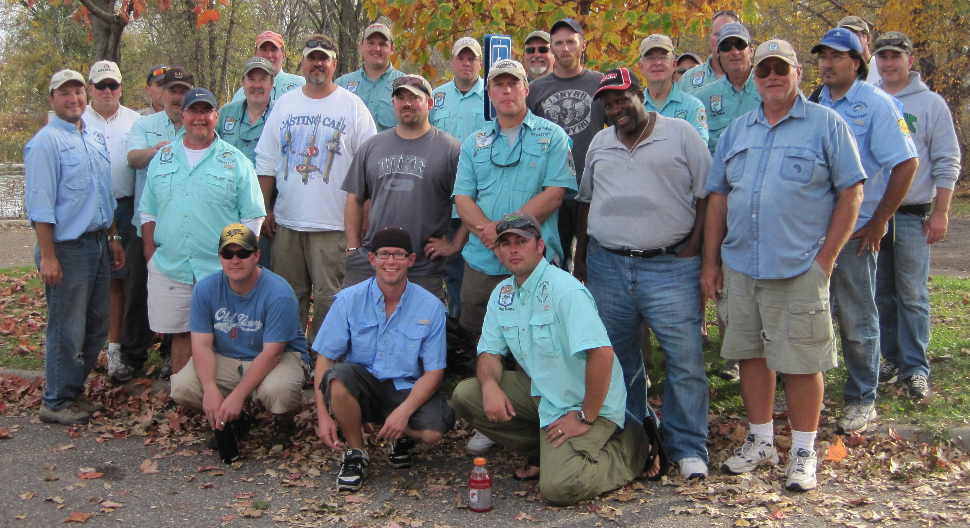

Sportsmen Bassmasters will promote your business:
1) You will have the opportunity to present your business at a club meeting.
2) We will wear jerseys advertising your business at Round Lake (WI), Waconia, Ida, Chisago, east metro area and Minnetonka club tournaments, monthly meetings, and the Minnesota B.A.S.S. Nation Tournament of Champions at Vermilion (Tower, MN).
2) Recognized as a sponsor on our club’s web site: www.sportsmenbassmasters.com.
3) Invitation to other club events (e.g. youth/veteran events, club banquet)
4) Offer a fishing tournament or half-day fishing on a local lake for any of our sponsors (1-2 people from each sponsor) that are interested.
Jersey Placement
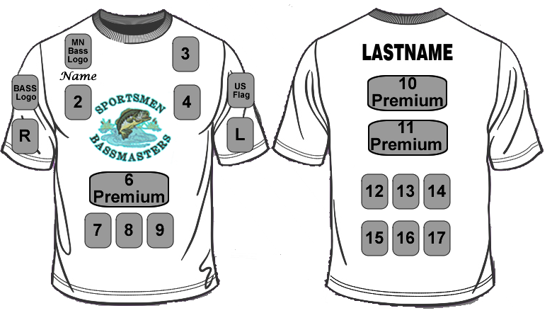Your business can be one the numbered logos. Placement is based on sponsorship level and priority will be first-come first-served. Tentative 2014 sponsors are: American Mortgage & Equity, and North Central Insurance.
Sportsmen Bassmasters Advertising Sponsorship Levels
 | $500  Gold | $1000  Platinum | $2000  Elite
Listed on website’s sponsors page | X | X | X
Listed on website’s home page |  | X | X
Invitation to club banquet | X | X | X
One paid banquet dinner |  | X | X
Logo on jersey | X | X | X
1 premium logo placement on jersey |  | X | X
2 premium logo placements on jersey |  |  | X
Framed club photo |  | X | X
Banner at club events and tournaments |  |  | X

Please make your check payable to Sportsmen Bassmasters and mail to:
Dave Huttner
Sportsmen Bassmasters Treasurer
22355 126th Ave N
Rogers, MN 55374
Thank you with heartfelt gratitude for your support of Sportsmen Bassmasters.

